**Adobe Premiere Pro CS6 31469352**

Adobe Premiere Pro CS6 is the latest version of Adobe’s video manipulation software, enabling the user to import, design and export clips. Through Premiere Pro, the user has the ability to edit the visual and auditory outcome of a video-clip. The user can also combine multiple video-clips and export the project in a variety of ways. The software takes advantage of many inclusive aspects, highlighting a large number of file formats supported, enabling the user to customise their digital workspace (GUI) to suit their needs physically and mentally. Having numerous purchase options based on an individual’s occupation and financial status expands the overall inclusivity of the software. Unfortunately, Adobe Premiere Pro is a very power-consuming title causing rendering, playback and timeline errors. This indicates Adobe Premiere Pro inefficient for lower-end devices, affecting the design of the software.

Premiere Pro is a huge video software title meaning it must support various file types. The software has executed this to a high standard, supporting an extensive range of video, image and sound file types. For the user, this highlights the ability to import different file types into the one project, deleting the hassle of external file converters and duplicate files. This also eliminates any decrease in quality and the complications of locating files of different types but same names. The support of multiple file types boosts the ergonomics of Premiere Pro, decreasing the need for online usage, wasting time converting files, and increasing the overall efficiency of the individual.

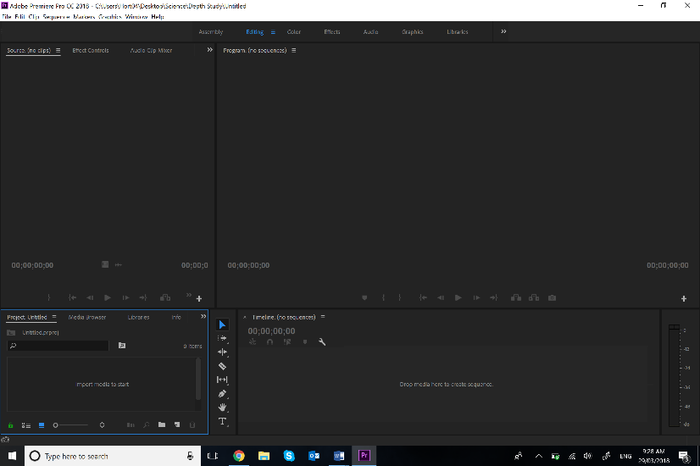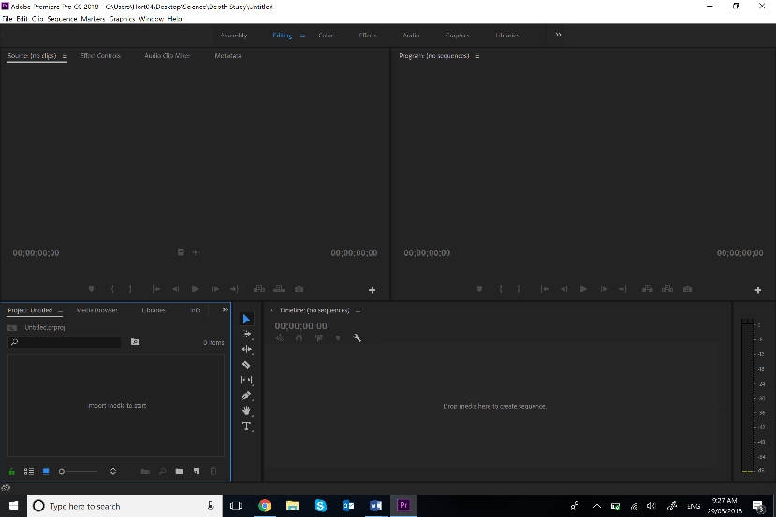Adobe Premiere Pro has the option for the user to customise their GUI to suit their needs physically and mentally. Premiere Pro has a large range of features available to the user. Some of these features are vital to controlling the video-clip. Extended, more advanced features that aren’t used as frequently can distract, confuse and slow down the performance of the individual. With Premiere Pro, the user can determine what they choose to ‘paste’ onto their workspace, how large they want the feature to be and how visible it is upon the screen. Participants suffering from poor sensory abilities such as vision impairment can take advantage of these resizing options. Mentally, being in the most comfortable digital environment boosts an individual’s efficiency and furthermore, the overall outcome of the project.

**File**

**Importer**

**Effects**

**Manager**

**Playback**

**Effects Manager**

**File**

**Importer**

**Timeline**

**Timeline**

**Playback**

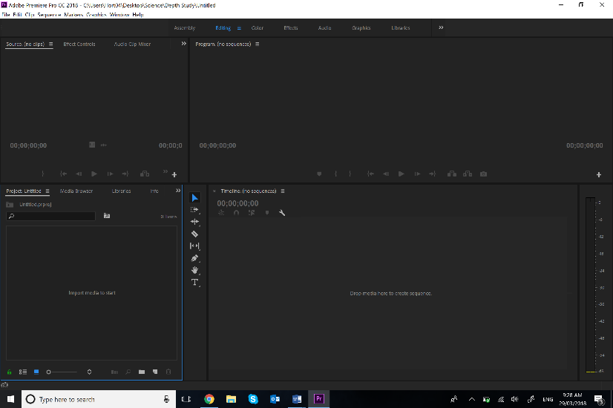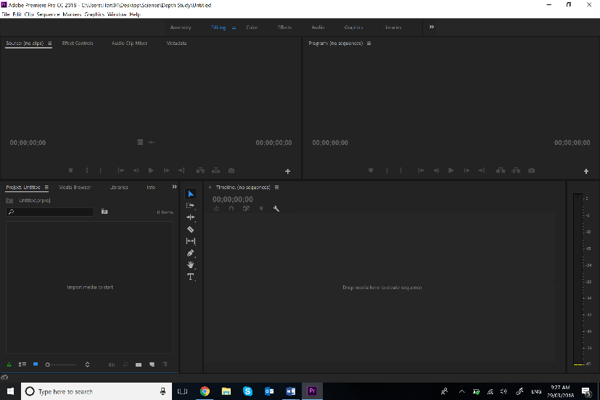

**Effects**

**Manager**

**Effects Manager**

**Playback**

**Playback**

**File**

**Importer**

**File**

**Importer**

**Timeline**

**Timeline**

Adobe Premiere Pro and other Adobe titles provide individuals with a selection of price points to suit their occupation and financial status. Premiere Pro is one of the most popular and elaborate video editing tools. It is because of this, the software is one of the most expensive titles. For students, a balance between a healthy study routine and a stable work income is hard to maintain. This is especially crucial for students studying courses that require video-manipulation software. Adobe recognises and takes advantage of the situation, providing students and teachers with an ‘educational discount’. For teachers, the stresses of gaining tax back on monthly/annual payments can be eliminated. On the condition, the student can provide proof they attend a school, and a teacher can confirm they ‘are’ a teacher; discounts of 40%-67% are applicable. There are no limits or disadvantages paying through an educational discount. Not only does this provide students and teachers with a reliable form of software for a cheaper price, but also extends accessibility and further, inclusivity.

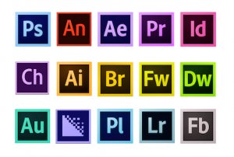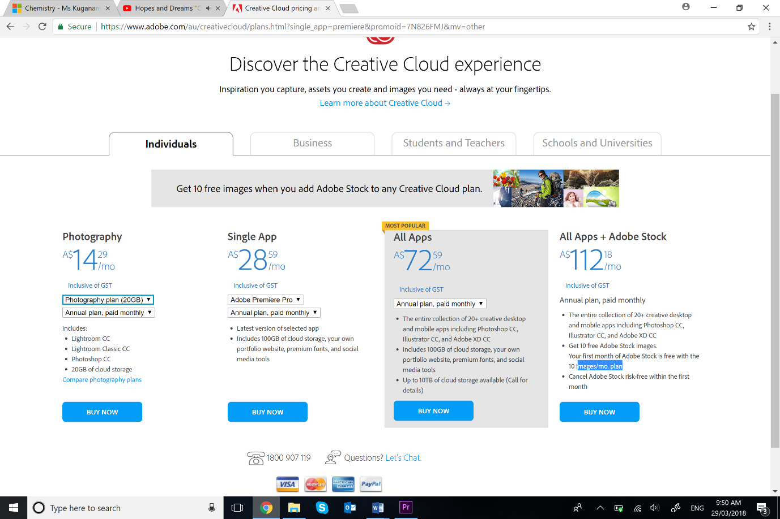



Adobe Premiere Pro has a very high processing requirement causing many low-end devices to falter under the stress of running the software, affecting the ergonomics of the title. Adobe Premiere Pro has a variety of tasks it must complete in order to display an output to the viewer. Video rendering, time-line manipulation, effect managing, nested sequences are all processes the software must confirm and incorporate in order for the output to function correctly. On top of this, the user must have the sufficient amount of storage to install the software and store completed projects. Currently, many devices cannot run Premiere Pro due to a lack of Core Processing Power, RAM and storage space. Low-income households cannot afford the hardware required to run the software. Adobe Premiere Pro does make an effort to spread RAM usage throughout other Adobe titles however; this is useless for single title users and the company recommends 8 GB dedicated to Premiere Pro. If a user wants to gain the most out of Premiere Pro; preview resolution, media playback and track number capabilities will be limited, causing question in software efficiency.

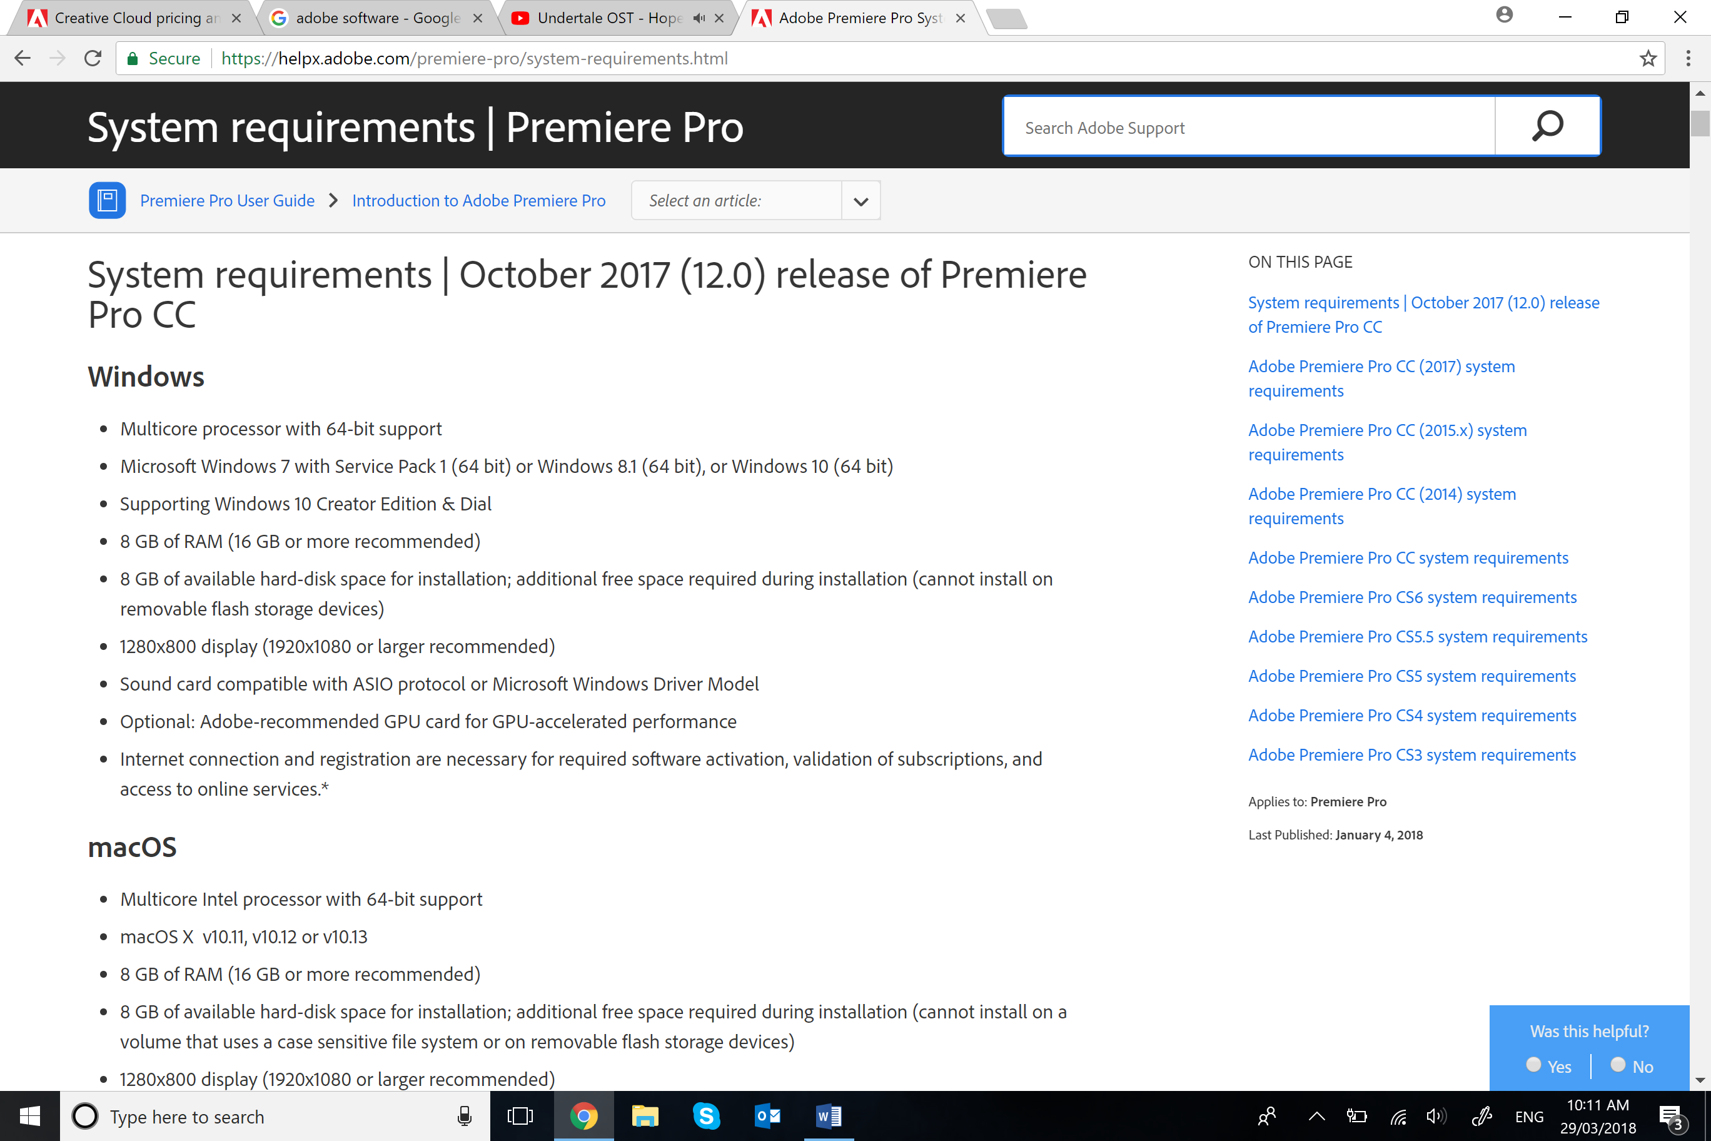

**Additional space required on top of installation**

**64-bit programs require extra RAM**

Adobe Premiere Pro CS6 satisfies the core criteria of user-friendliness, allowing the user to import various file types, customise the GUI to promote physical and mental wellbeing, and reach certain price-points to aid students and teachers. The title does not depend on third-party software to export high quality media and, provides users with a simple installation to prevent confusion and further impact on the performance of the software. Unfortunately, Premiere Pro has very little support for low-end devices, limiting the inclusivity of the product, influencing the overall user-friendliness of the product.